

YTP - Module YTP01

Arduino & Micro-Controllers

**Teachers Handbook LESSON 2**

**What is an Arduino?**

# Goals & Success Factors

### Lesson Goal

* To understand the question “what a micro-controller?”
* Learn about different types of Arduino
* Learn how to setup an Arduino
* Understand Analogue and Digital
* Learn how to create the most basic Arduino project

### Lesson Success Factor(s)

* Setup an Arduino successfully
* Complete the Arduino Blink project

# 

# Runsheet (Guideline)

00:00 Introduction

00:05 Goals & Success Factors

00:10 What is an Arduino?

00:20 Analogue vs Digital

00:25 Arduino PINs

00:30 Build Blink Circuit

00:45 Code & Test Blink Circuit

01:00 Finish

**Extension(s)**

Change the resistor

Add another LED

# Students Pre-work

Watch the following video:

**Introduction to Arduino:** youtu.be/09zfRaLEasY

# Teachers Pre-work

Watch the following video:

**Introduction to Arduino:** youtu.be/09zfRaLEasY

# Student Homework

Watch the following videos:

**Recap of Arduino hardware and software**: bit.ly/ytp01-led-blink

**Knowing your way around the Arduino Editor**: bit.ly/ytp01-the-arduino-editor

# Handouts (optional)

Please download from: https://github.com/nexgencodecamp/ytp/modules/arduino

# Handbook

## Definitions

Arduino is an open-source electronics prototyping platform based on flexible, easy-to-use hardware and software. It’s intended for artists, designers, hobbyists, and anyone interested in creating interactive objects or environments.

*Source:* [*http://www.arduino.cc/*](http://www.arduino.cc/)

The Arduino may prove to be one of the most important inventions of the 21st Century. The first micro-controller to bring physical computing to the masses, it has opened up a world of possibilities to all of us. Not just for engineers or coders, the Arduino was always intended for people such as artists, designers, hobbyists and creatives (see above quote)

*Source: Pete Januarius - Nexgen Codecamp*

## What does it look like?

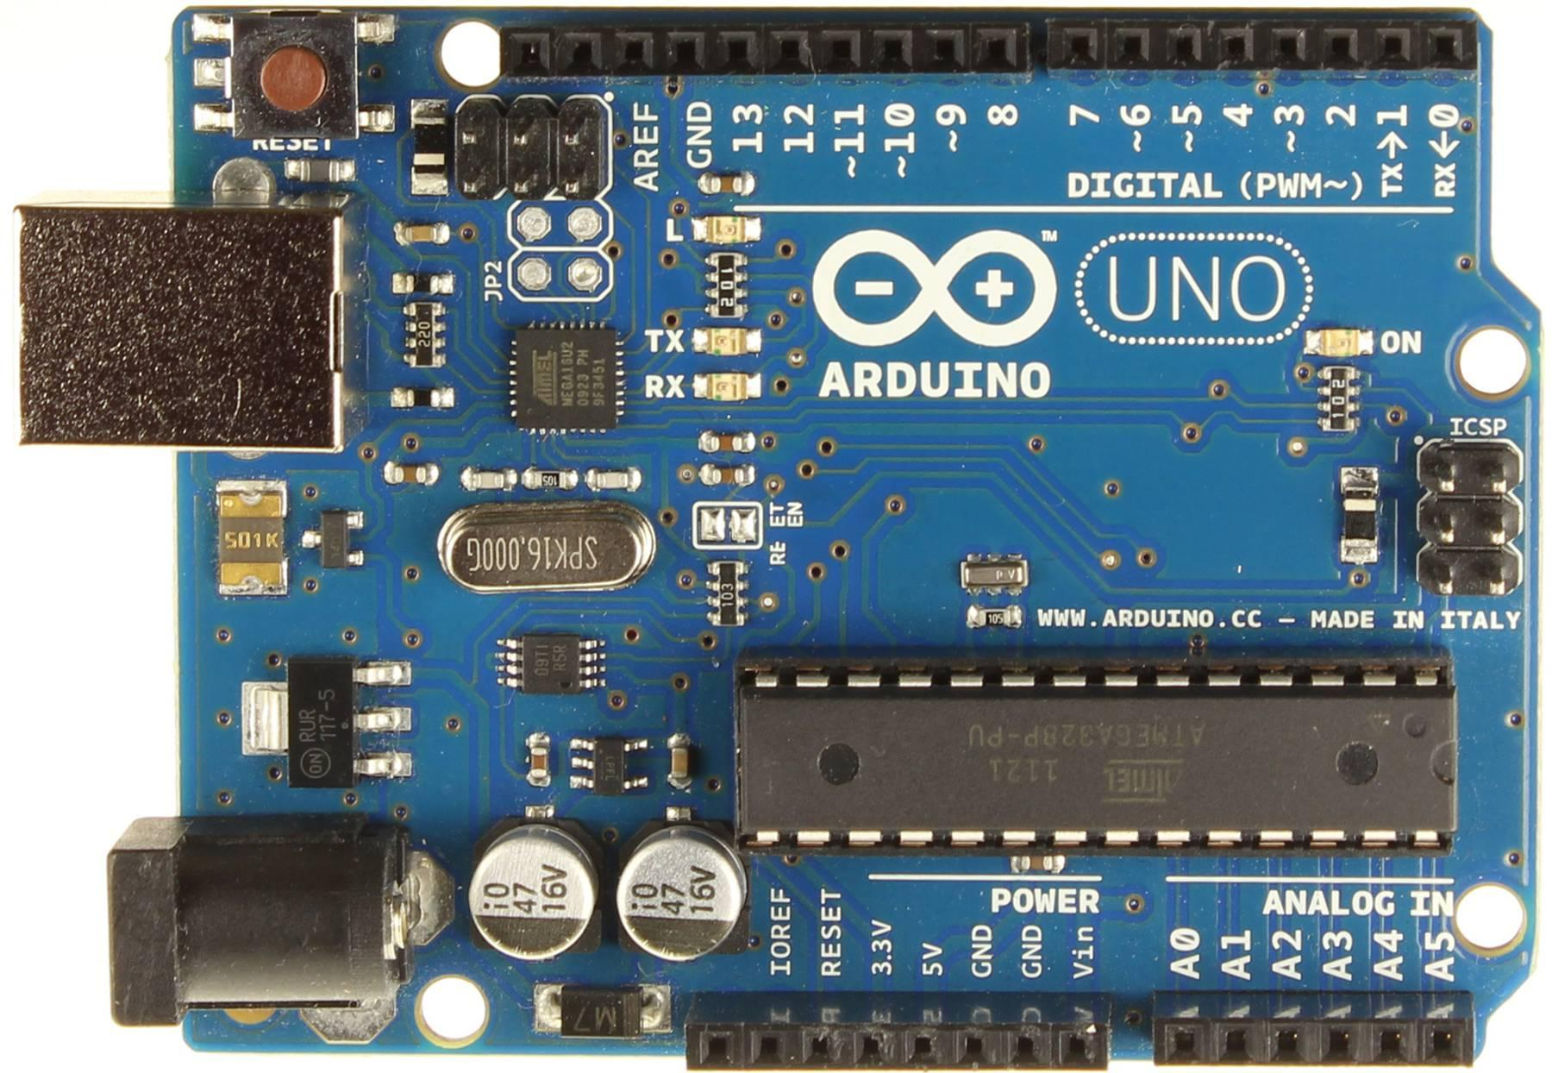**The Arduino UNO**

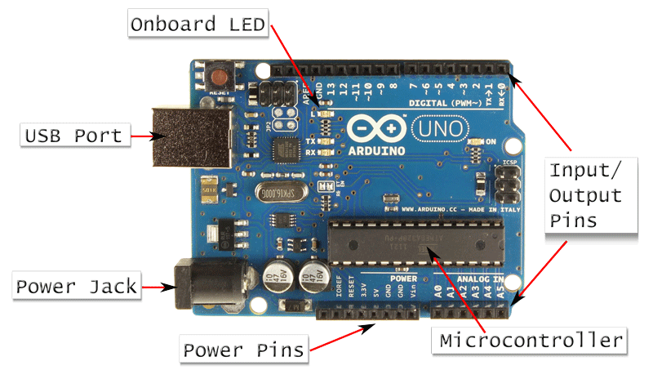

### Microcontroller

The brains of the Arduino. This is the chip everything is built on.

### USB Port

This is where you connect your USB cable

### Onboard LED

A helpful Light Emitting Diode that you can use to test your Arduino with the classic Blink sketch (blinking an LED on and off).

### Power Jack/Power Pins

Supply power to the Arduino. Look at the following diagram. This gives you a clear idea of what you should use in terms of voltage for each option:

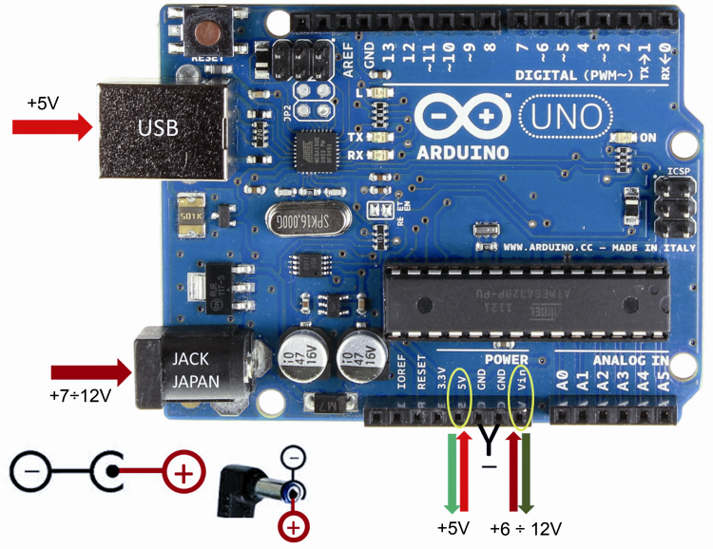

Note that the 5v pin (circled in yellow) is an unregulated supply so you should NOT put more than 5v through this. In actual fact, we recommend that you never power the Arduino from this pin. Instead, if you are using batteries, connect the positive to the VIN pin which is a regulated supply between 6v and 12v and connect the negative to GND.

*Do not power from both the VIN and the (barrel) jack at the same time as dangerous conflicts may occur.*

Using the USB port will use the power from your computer to power the Arduino. This is fine for development and testing but obviously not when you want to deploy a project.

If you use the 7-12v barrel jack then you MUST use an external source (normally a power supply but can be batteries. You can actually use between 6-20v to power the Arduino but the recommendation from the manufacturer is 7-12v.

### Input/Output Pins

Input and Output pins are the mechanism by which we read data in to the Arduino and push data out from the Arduino. Input data comes ‘in’ from a component such as a button or a temperature sensor. In the case of a button, the input data is simply an ‘on’ or ‘off’ value. In the case of the sensor it is a temperature reading (in actual fact probably a voltage reading). The input value is then at your disposal and available to your Arduino program code. Output data is data that originates from your code and is then ‘sent’ to an output pin which could be connected to a display, motor or some other device expecting to be ‘sent’ some values from the Arduino in order that it may be controlled.

## How do we use an Arduino?

So you might be thinking “What do I actually do with an Arduino and how do I use it?”. Both great questions. There are a few key points to note about Arduinos and micro-controllers in general (Note that an Arduino is just one example of a micro-controller):

1. An Arduino (or a micro-controller for that matter) can be thought of as a simple computer, sort of like an insect brain as opposed to a complex/powerful computer which could be likened to a human brain.
2. It does not do multitasking like an operating system such as Windows. It can only run one program at any one time. If you want to run a new program on an Arduino you must overwrite the previous one. This is what it is built for. Arduinos do one thing and they do it very well.
3. Programs are *uploaded* using the Arduino IDE software (<https://www.arduino.cc/en/Main/Software>?) which itself is installed on your Win/Mac/Linux machine.
4. You create or write programs for the Arduino in a language called ‘C’ using the Arduino IDE software.
5. The real purpose of an Arduino is to enable us to control or sense the physical environment around us. The Arduino makes it incredibly easy. Here are a few examples of the kinds of things we might do with an Arduino:
   1. Turn an LED (light) on and off
   2. Read the current temperature and humidity
   3. Make a security alarm based on the ability to sense moving objects
   4. Make a simple musical instrument
   5. Make a line following robot
   6. Make a remote control using IR (Infra red)
   7. Sense the composition of gases
   8. Turn a motor
   9. Control one or more servos (motors)
   10. Make a simple or complex robot
   11. Make a traffic light
   12. Make an autonomous robot
   13. Control an LCD display
   14. Test the moisture level in the soil
   15. Make a morse code signaller
   16. Communicate via bluetooth
   17. Test the air pressure
   18. Make your home automated
   19. Light up LEDs as Christmas lights via Twitter (I’ve done this)
   20. Build a game controller
   21. Build a remote controlled car
   22. Build a light up doggy collar for those night walkies
   23. Build a food dispenser for your pets
   24. Make light up shoes that sense the steps you take
   25. Make an LED light up T-shirt based on temperature
   26. Make a LCD alarm clock

We are convinced that given a bit of time and some thought, anyone can not only come up with their own project, but they could build it pretty easily too!

Just to help you piece together the picture a bit more, here is the general setup that you would employ if you were using an Arduino - in other words - if you were writing some program for your Arduino that you wanted to upload:

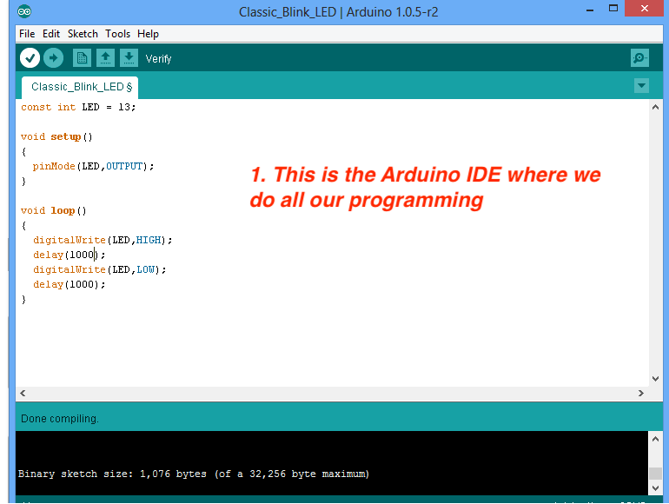

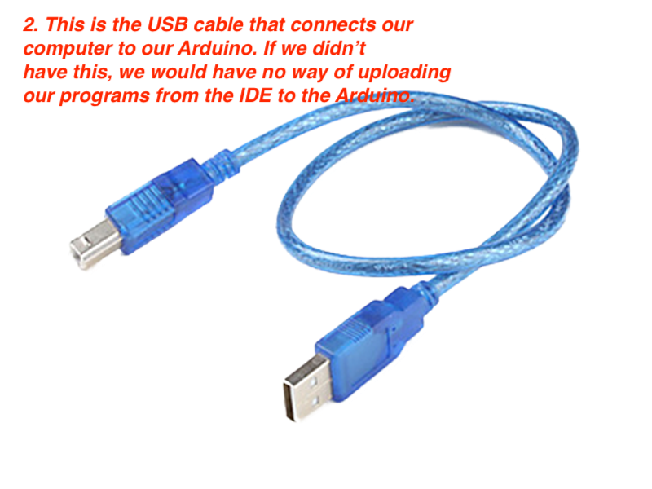

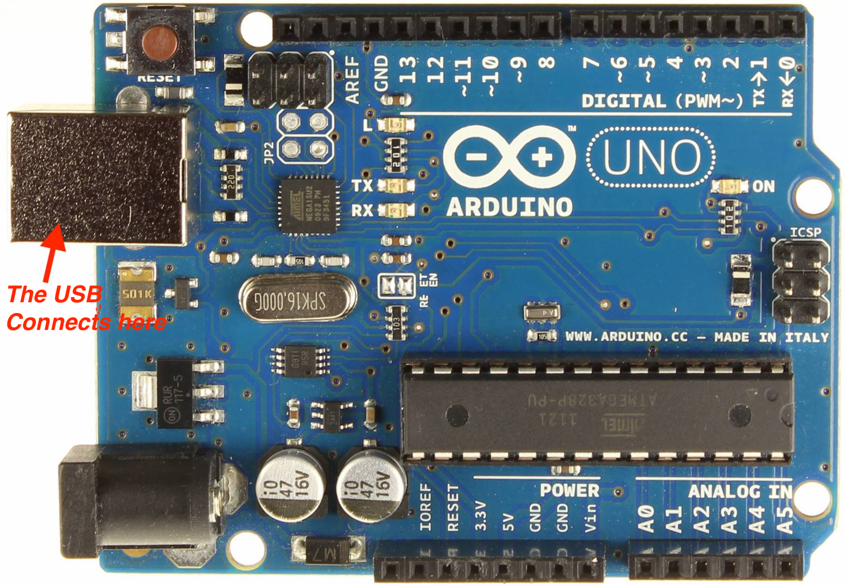

## Arduino Form Factors

Arduino is based on an open source design which means that anyone can take the technical specification and create a product of their own design. Hence there are many different types of Arduino out there - we call these different form-factors. The one we will be using is the Arduino UNO. Generally speaking, this is the easiest one to use when you are starting out with micro-controllers. The pin headers make it very easy to connect circuits together.

**Arduino Pro-Mini**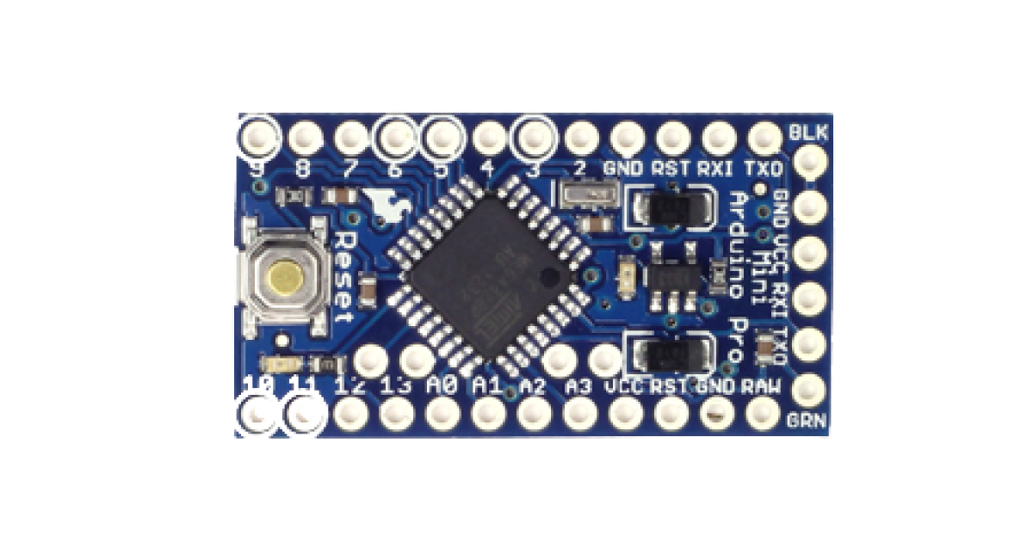

**Arduino YUN**

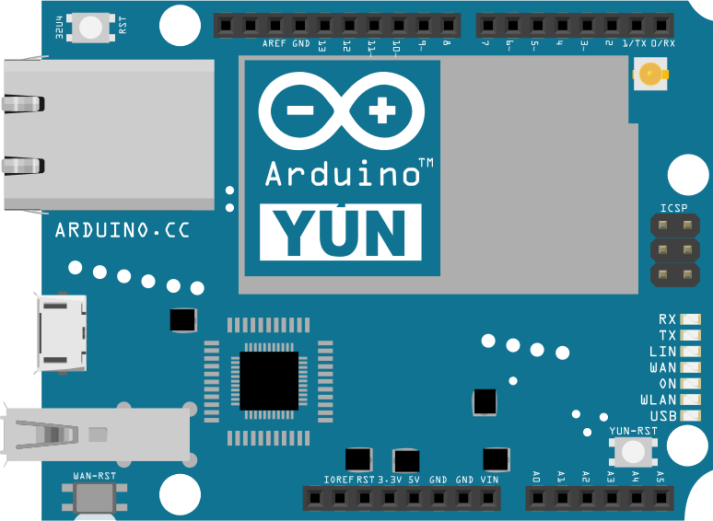

**Arduino Nano**

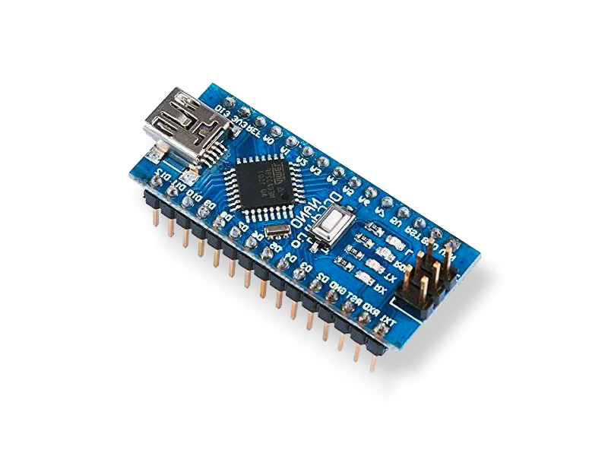

**Arduino Mega**

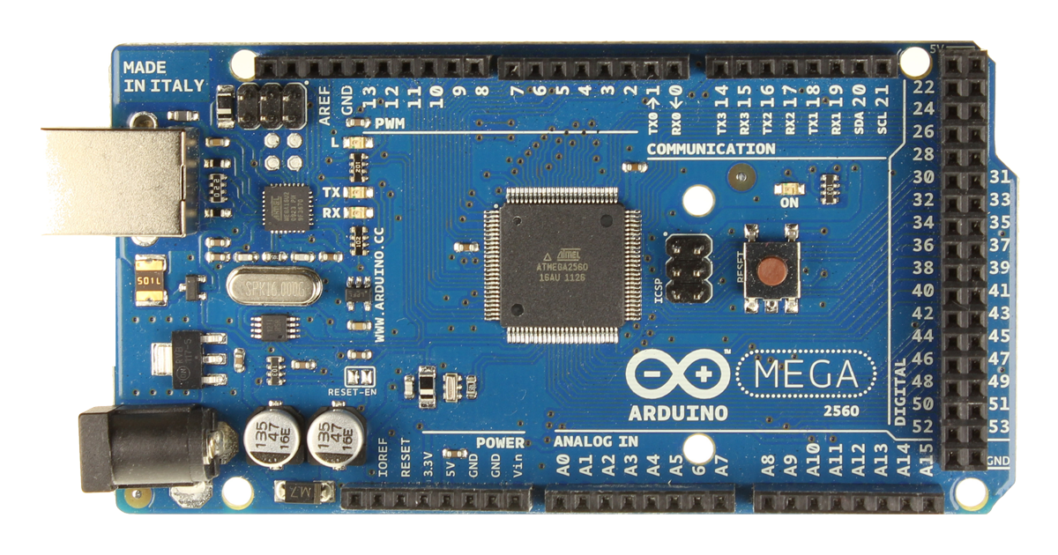

## 

## Arduino Clones

There are also many clones out there on the market. In other words you could purchase a genuine Arduino UNO or you could purchase a cheap Chinese clone. These are absolutely fine although they use different software drivers based on the CH340 chip which must be taken into account if you buy these. Drivers for clones are hard to find (see resources).

**Genuine Arduino UNO**

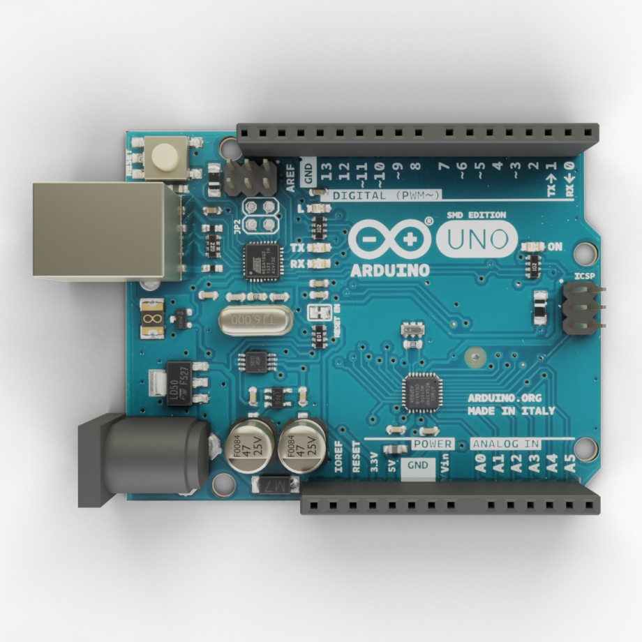

**Arduino Clone**

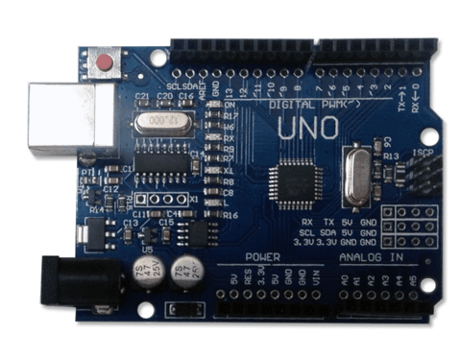

## Step by Step Arduino Setup and use

What follows is a simple step by step guide of what you will do 90% of the time when using your Arduino to code and upload a program.

1. Boot up your PC/Mac
2. Open the Arduino IDE application
3. Plug the USB cable into the Arduino and your PC
4. Select the correct board

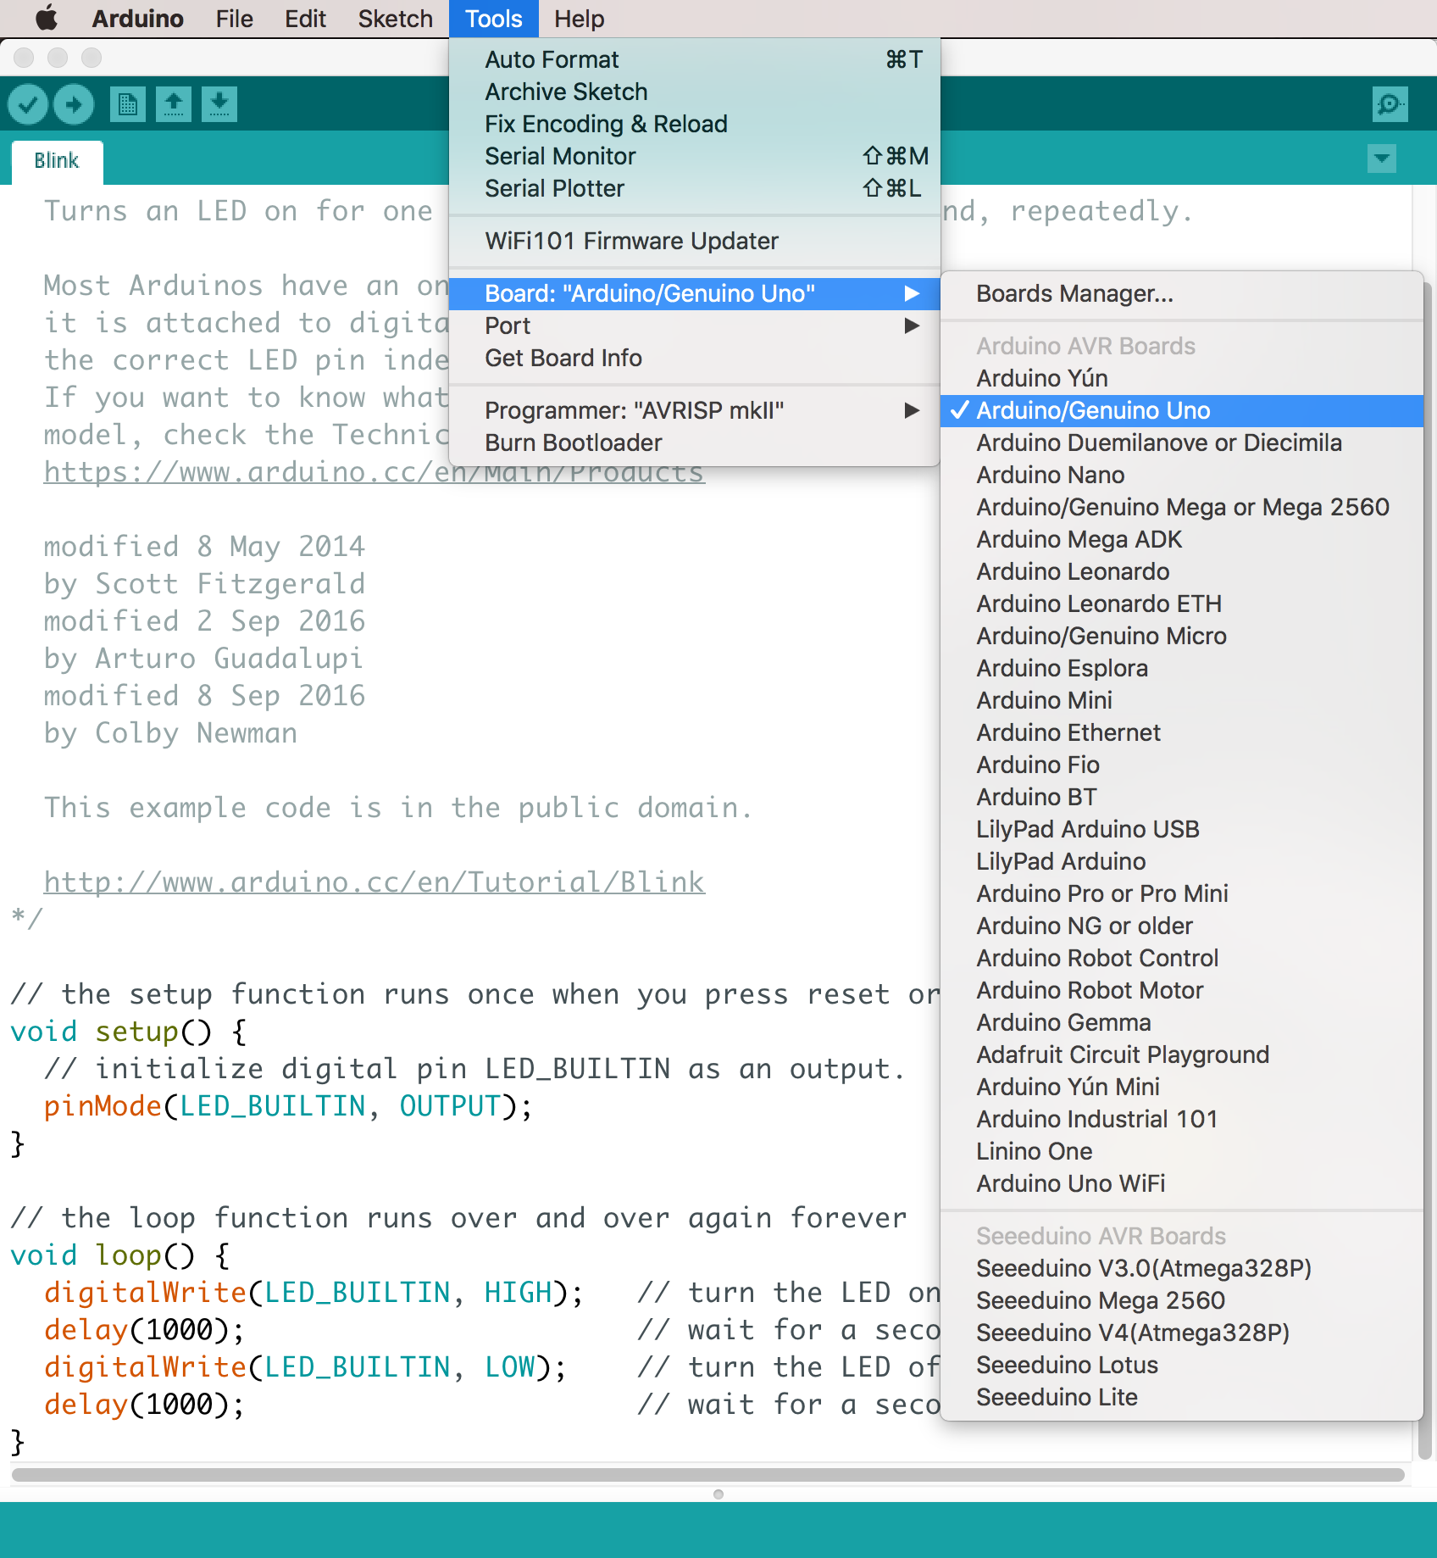

1. Select the correct port

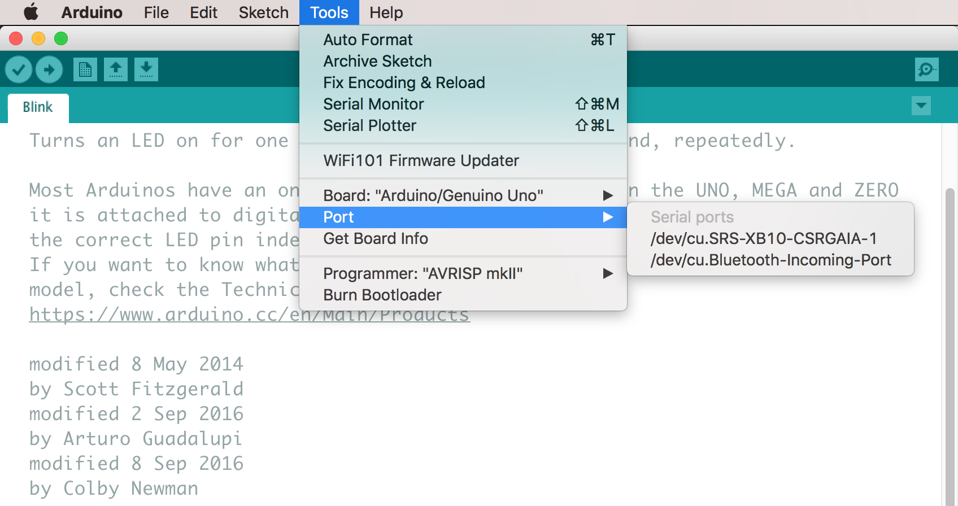

1. Your Arduino is ready!
2. Next steps….
3. Write your code in the Arduino IDE application (see next section)
4. Verify/Compile the code

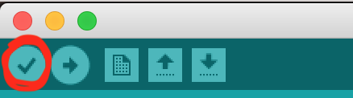

1. Upload the code

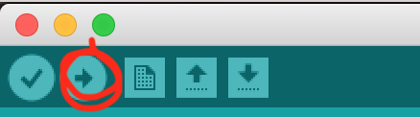

## A Very Quick and Easy Example

The canonical example of every single programming language in the World bar none (as far as I know) is ‘Hello World’. I remember doing this aged 13 on my VIC-20 in BASIC in the early 1980s. Basically (excuse the pun) you print out the words ‘Hello World’ to the screen. In the Arduino version, we blink an LED on and off. So firstly you will need the following parts:

1. An Arduino
2. A USB cable
3. Arduino IDE installed on your laptop/computer be it Mac or Windows

“Where is the LED?” I hear you say! Well - we will be using the onboard LED which is internally connected to pin 13. We will configure pin 13 to be an output pin because we will be sending some output data to it ie. an on or off value (one or zero) every 1 second.

Open up the Blink sketch. You will find it in: File -> Examples -> 01.Basics -> Blink

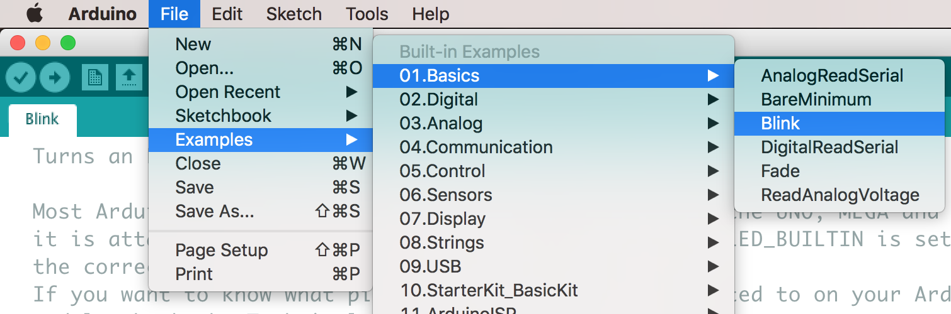

You will see the following code:

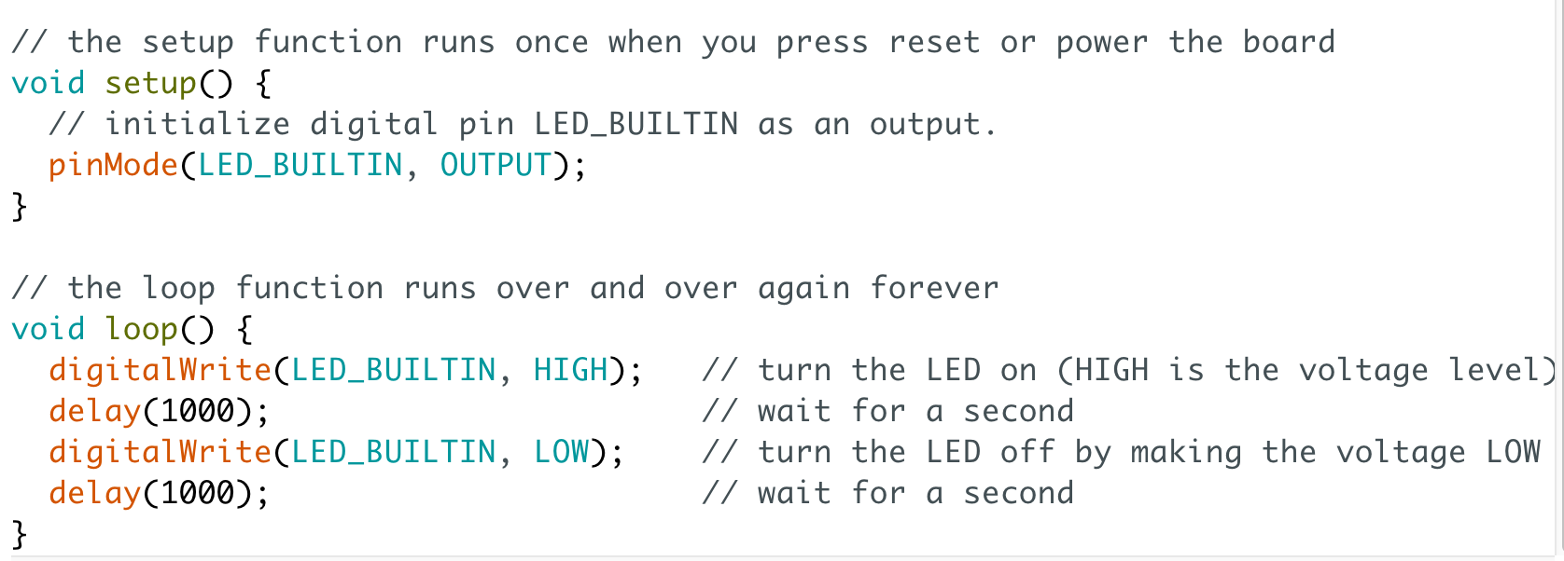

Let’s take this one step at a time…

### setup()

setup() is one of two *functions* that belong to every Arduino program. Firstly a function is essentially an action that a program can take. In the case of ‘setup’, it is actioning the configuration of any pins, declaring variables (placeholders or buckets for data values) and anything else that it might need to do before the main program runs. It is kind of like an initialisation routine that any electronic device goes through when you first switch it on.

### loop()

The second function is loop(). This is very straightforward. It essentially runs the code inside the function and then repeats ad infinitum… until you power your Arduino off. The code inside the loop() function above turns the LED on, waits 1 second, turns the LED off, waits 1 second and is then finished. The loop then repeats….the LED turns on, waits, turns off, waits…..and so on.

### Setting the pin mode

Remember that we said that pins can be used for input or output? The pinMode instruction determines which it is. So for example in the code above we are setting the inbuilt LED to be an output pin so that we can ‘send’ data to it, the data being a high or a low value which translates to a high voltage (turning the LED light on) or a low voltage of zero (turning the LED off):

pinMode(LED_BUILTIN, OUTPUT);

This could also have been written:

pinMode(13, OUTPUT);

As LED_BUILTIN is basically a constant value equal to 13.

In this particular example we are not receiving input from any device, button or sensor so we do not need to configure any pins for input.

### Writing to a pin

An output pin is only useful if we can write a value to it. We do that with this instruction:

digitalWrite(LED_BUILTIN, HIGH);

HIGH is a constant representing the number 1. You will also see LOW which you can read as 0. Note that we do not have a need to read from any pins. If we were to do so we would use the instruction: digitalRead.

### Waiting…

The code delay(1000) waits for one thousand milliseconds.

And that’s it !! Well not quite….

### Verify the Code

As described in the previous section, you verify your code by clicking the button in the toolbar shown below. Do this now. The code should compile because it is one of the standard examples and not something that we have written ourselves.



### Upload the Code

Once verified, click the button shown below. This physically transfers the code to the Arduino. The code will be stored on the Arduino until it is overwritten by another program.



## Analogue & Digital

So there is one concept that we haven’t covered yet that is crucial to understanding electronics. The concept of analogue and digital signals. You know what these are, you just may have trouble articulating the definitions.

A Digital signal can have one of two values: on or off, 1 or 0, true or false, yes or no.

An Analogue signal is continuous - in other words it is 0, 1 and potentially every value in between.

An oldie but a goodie: <https://youtu.be/-43VsMXz7U0>

Here is a more modern explanation: <https://youtu.be/btgAUdbj85E>

## Arduino Folders and File Locations

It is definitely worth knowing a bit more about where the Arduino stores all of its files. This will help you when you need to install libraries or move sketches (sketch is the Arduino term for a computer program). Our examples are taken from a Mac but Windows applies also.

When you install the Arduino IDE, it creates an ‘Arduino’ directory (folder) in your Documents directory. Inside the Arduino folder you will have the following directories (sometimes these are not created but you can go ahead and create them):

libraries - contains third party library code

sketches - contains your sketches (programs)

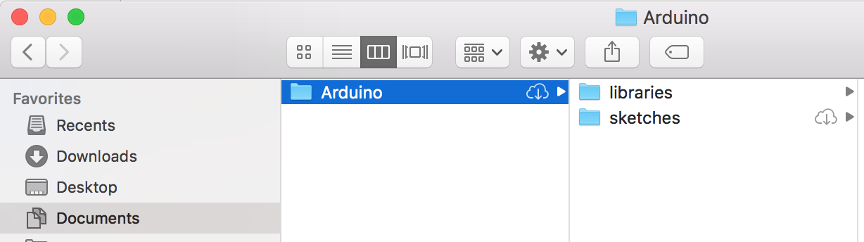

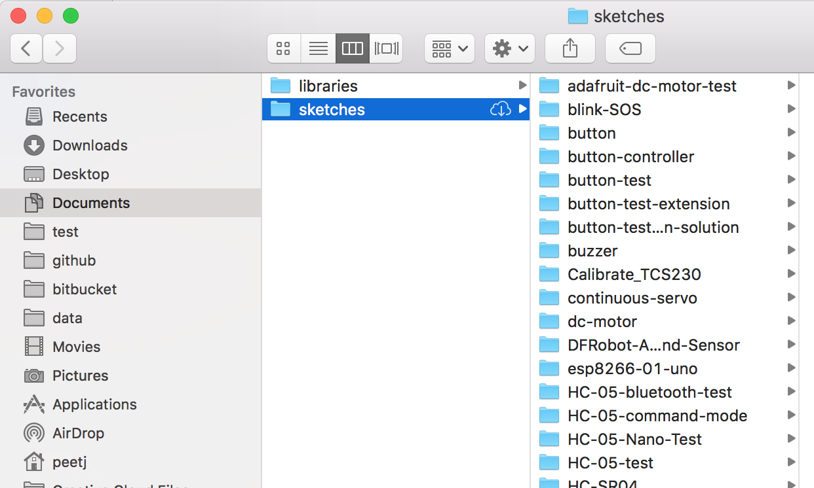

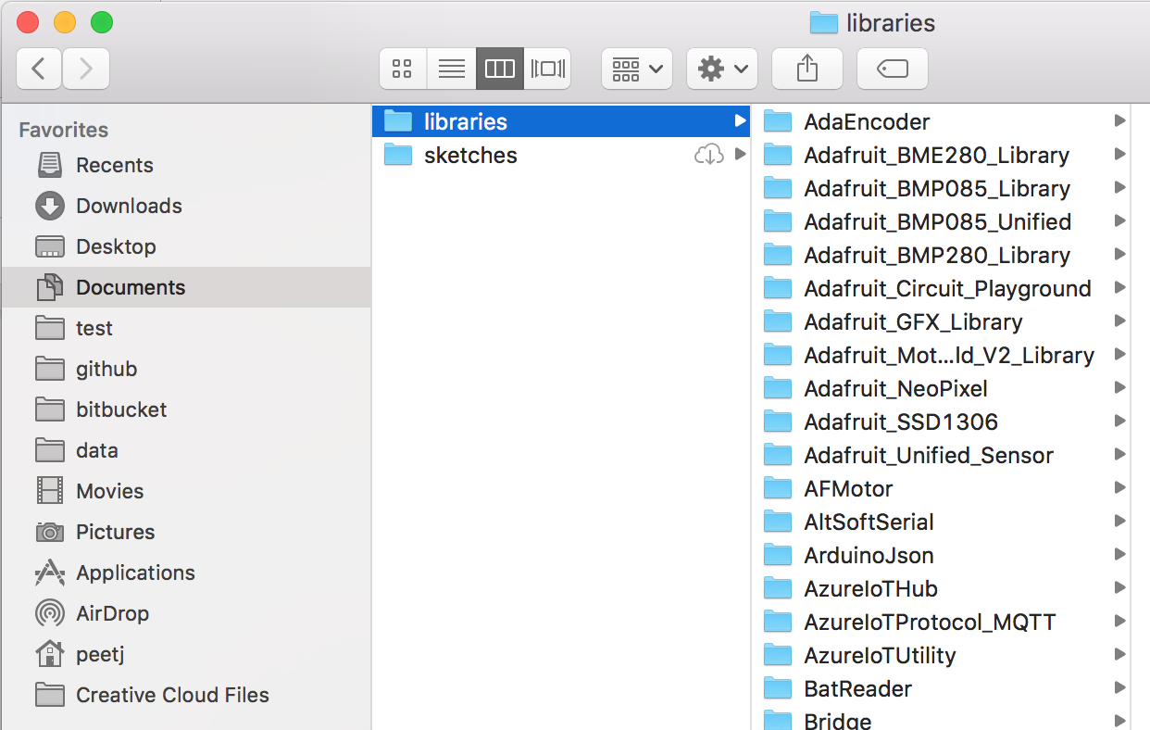

## Arduino Settings

Open your Arduino Preferences... menu option:

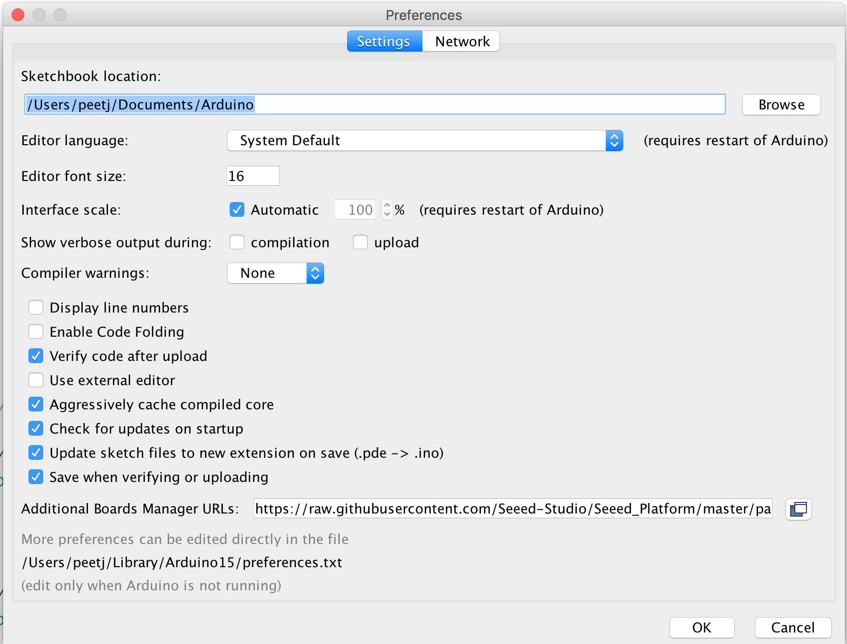

Note the Sketchbook location which you can access from inside the Arduino IDE from the File -> Sketchbook menu option.

Note also that you can change the font size of the text in the code window.

## 

## What happens when it all goes wrong?

The following issues are the most common issues that we have seen from plugging in Arduinos thousands of times. This is by no means an exhaustive list. Instead we have listed a more comprehensive list in the Resources section at the end of this lesson. The issues below are the ones we believe to be the ones you are most likely to see in practice:

**I cannot see the correct port when I plug in my USB cable**

Pull the cable out and reconnect. If this doesn’t work, try another USB port. If this still doesn’t work, restart the IDE and reconnect the cable.

**When I try and upload my code, it won’t upload**

Is the USB cable connected properly? Yes? Check the Tools -> Port to make sure the port is selected. If all else fails, shut down the IDE, pull your cable out and reconnect

**The port is disabled when I go to select it (greyed out)**

Sometimes it takes a few seconds to show up, however if it does not show up at all then you probably haven’t installed the necessary drivers. With genuine Arduinos, the drivers are installed with the IDE. With clones, you must download the CH340 drivers (see the resources section at the end).

**My code won’t compile**

You more than likely have a syntax error. Have a look at the error message in the editor console. It usually tries to tell you where the mistake is and what it was. Usually for beginners, the mistake is a missing bracket or semi-colon. Remember in code we typically use the full range of bracket types: (), {} and [].

**Oops - I didn’t mean to press that key combination**

Ok so you made a mistake in the Editor? It happens. Just use this key combination to get out of trouble: CTRL-Z

**Where do I install third party libraries?**

Easy - in your Documents/Arduino/libraries directory (folder). If the libraries folder does not exist, go ahead and create it.

## 

## Resources

Introduction to Arduino - 1

<https://www.youtube.com/watch?v=CqrQmQqpHXc>

Introduction to Arduino - 2

<https://www.allaboutcircuits.com/projects/getting-started-with-the-arduino/>

Arduino: Troubleshooting

<https://www.arduino.cc/en/Guide/Troubleshooting>

Arduino Clone Drivers

<https://sparks.gogo.co.nz/ch340.html>

How to spot an Arduino Clone

<https://www.arduino.cc/en/Products/Counterfeit>

10 Great Arduino Projects for Beginners

<https://www.makeuseof.com/tag/10-great-arduino-projects-for-beginners/>

10 Arduino Projects for Beginners anyone can make

<https://www.circuito.io/blog/arduino-projects-for-beginners/>

16 Beginner Projects

<https://create.arduino.cc/projecthub/projects/tags/beginner>

130 Arduino Projects

<https://circuitdigest.com/arduino-projects>

The Absolute Beginner’s Guide to Arduino

<http://forefront.io/a/beginners-guide-to-arduino/>